Ansible Controller manage 2 host

#add the Ip’s of host it could be n number for example purpose we tak 2 only

# edit hosts file by using sudo command and private ip of host note
$sudo –vi hosts

#you can authenticate your host node using private ssh key i.e (.pem) file
- Need to upload .pem from my computer windows to Ubuntu ec2 instance for that open gitbash
then add this following command
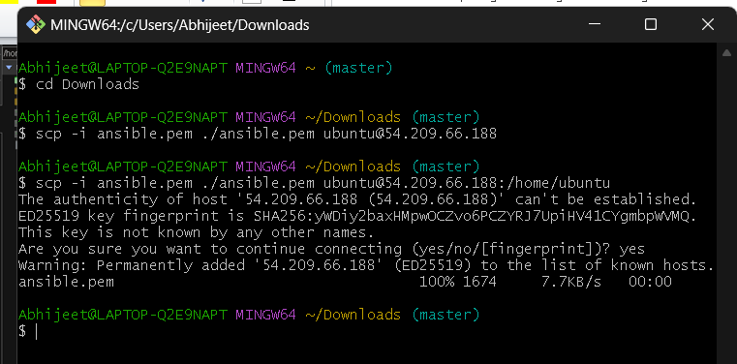
2) change the file path in hosts file

#check weather you able to ping node host using following command
$ ansible –m ping SL
Note: SL is nothing but a group name you can give anything

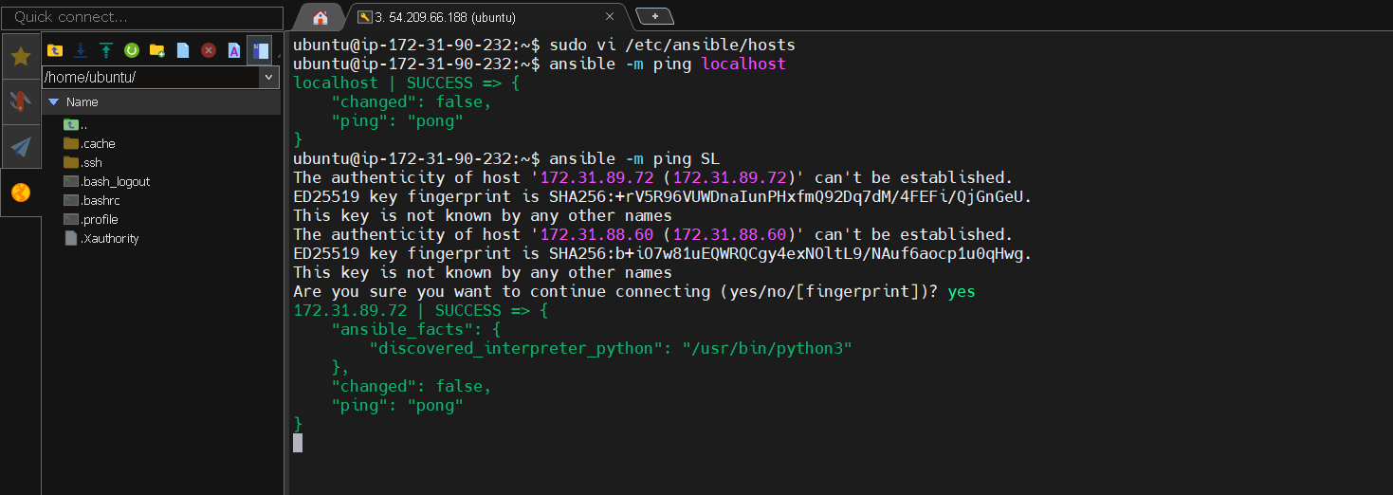

Note : In above example you see there is only showing one ip is given successful you have check for another you have to type ‘yes’ keyword again

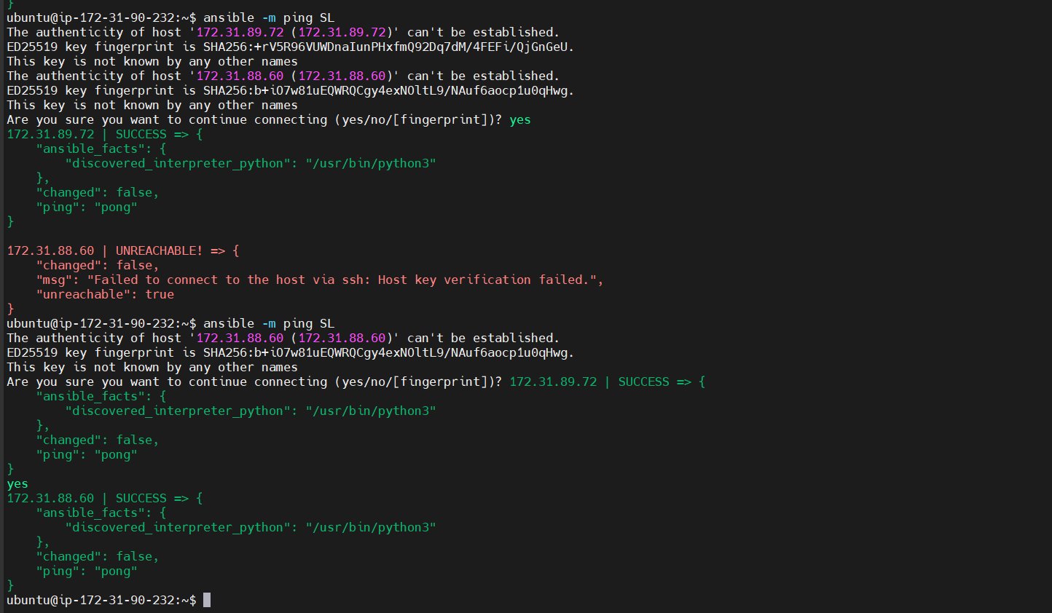

#Now if you get success for both 2 ips then you can create file on both host ect instance

$ ansible SL –a“touch abhijeet”

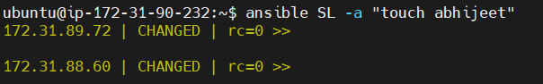

#To verify that Abhijeet file is created or not login to ec2 instace weather file created or not



As you can see in above Abhijeet file is created

